CHUK MEDICAL STUDENTS INTERNSHIP ONLINE SYSTEM
STEPS TO UPDATE STUDENT 3 LAST DOCUMENTS:

1st STEP: LOGIN INTO THE SYETM[www.chuk.rw/internship]
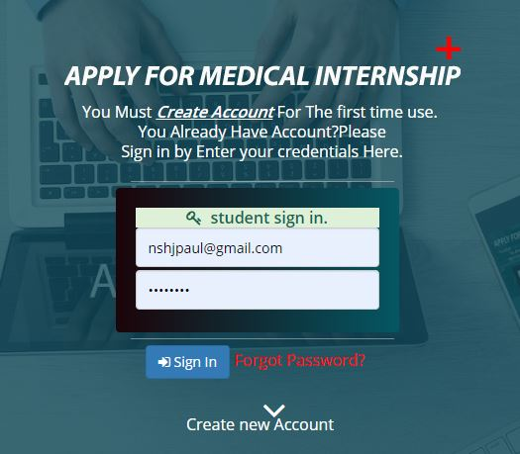

2nd STEP: CLICK APPROVED REQUEST BUTTON ON LEFT PANEL

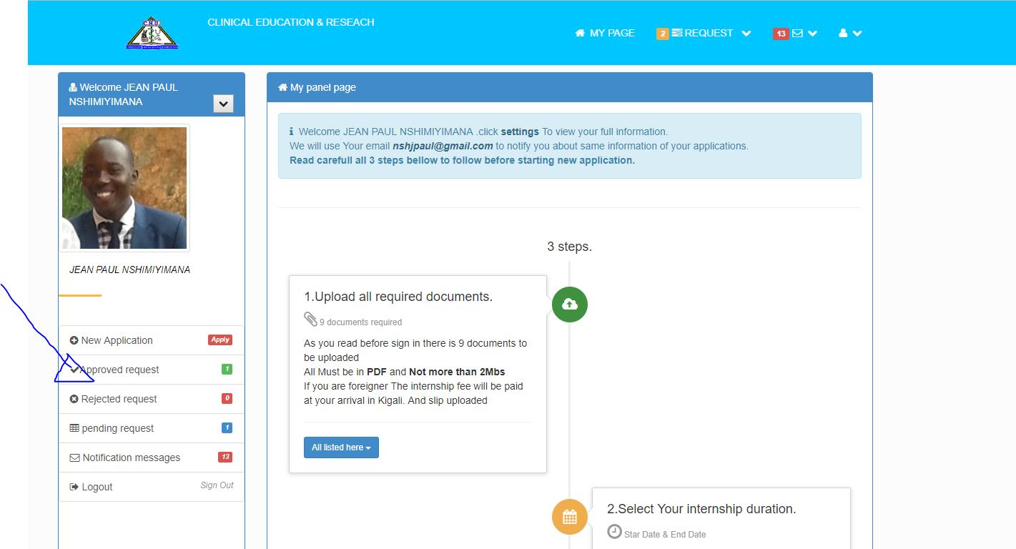

3rd STEP: CHOOSE REQUEST TO UPDATE:
On the table list of approved request click view button on request you need to update
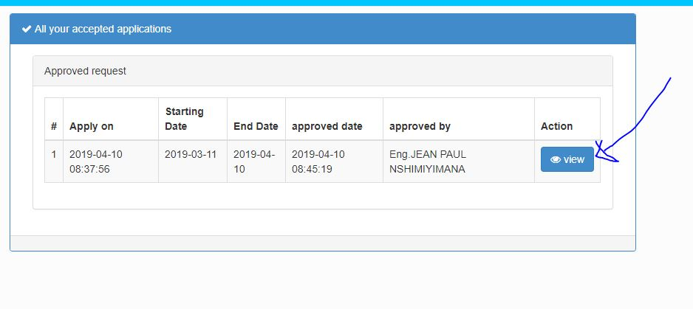

4th STEP: CLICK UPDATE BUTTON:

3 Last files have update button. Please click that button on file you need to update
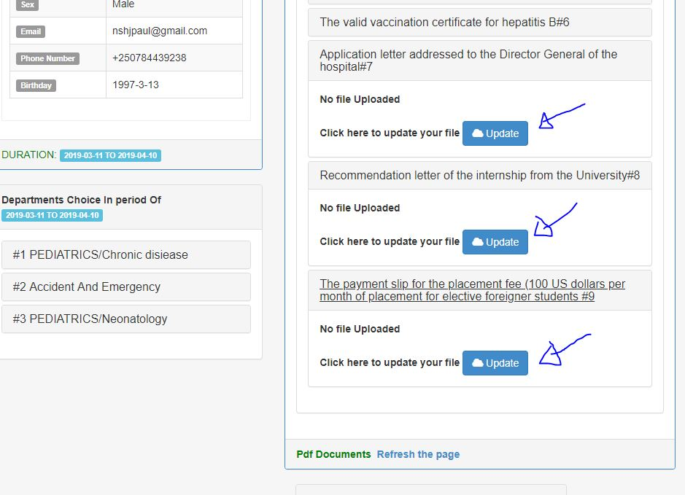
5th STEP: CHOOSE FILE AND UPDATE

Upload your file and click upload button
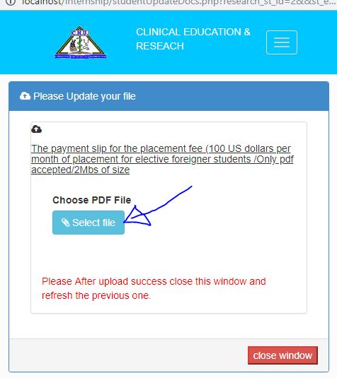

6th STEP: CLOSE OPENED WINDOW
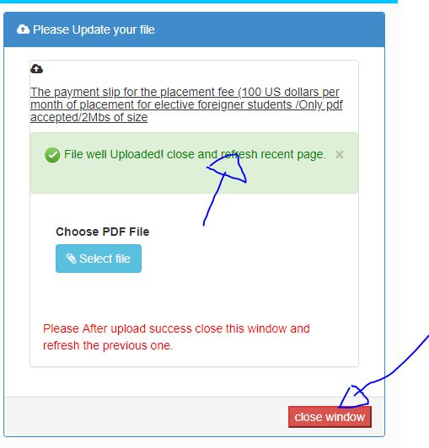
Click RED close windows button

7th STEP: REFLESH RECENT WINDOW

Click reflesh button on the bottom
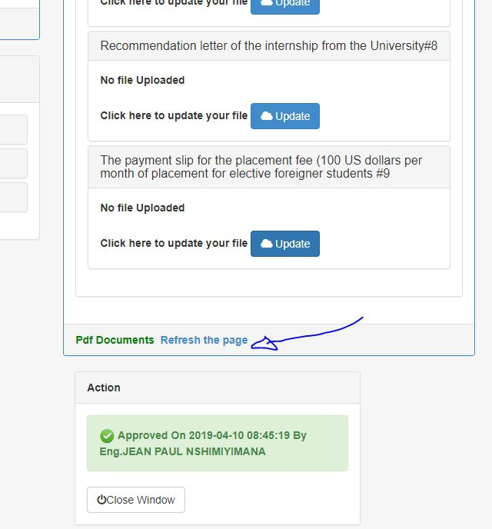
LAST STEP: CHECK UPLOADED FILE

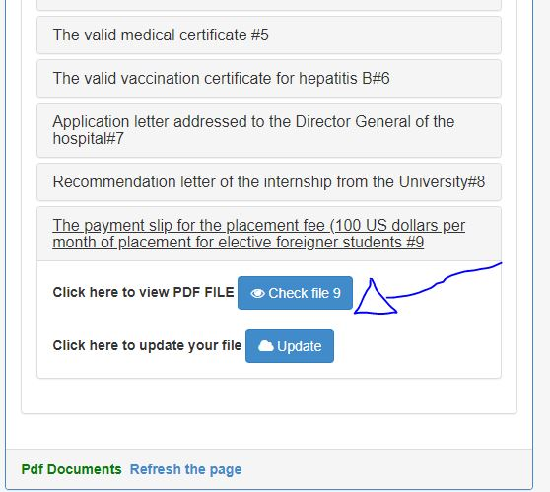
IT SUPPORT CALL:+250784439238,chuk.internship@gmail.com

THANKS ….......!!!!!!!!!!!!!

