CHUK ONLINE STUDENT INTERNSHIP APPLICATION SYSTEM LOGIN GUIDENCE

PLEASE FOLLOW THE STEPS BELLOW TO LOGIN INTO THE SYSTEM

1ST STEP

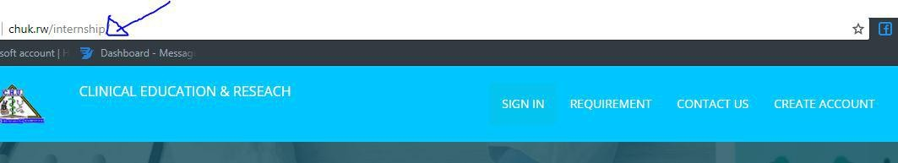Open any web browser:eg google chrome, mozilla, etc and in URL write chuk.rw/internship

2nd step: scroll down to bottom of page and click my H.O.D STAFF link

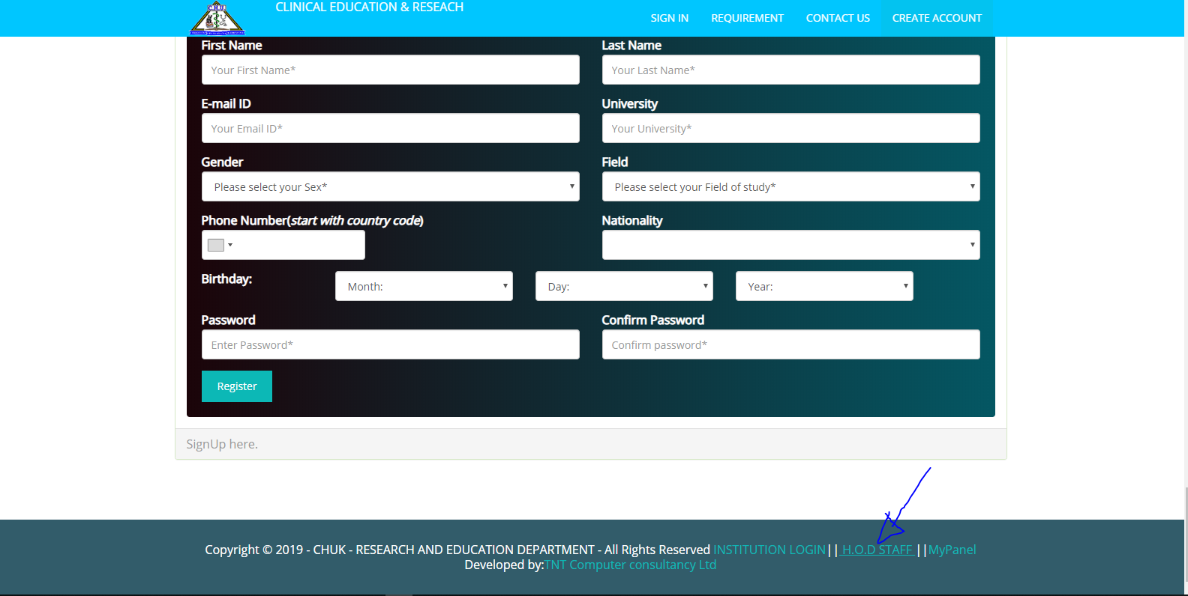

3rd STEP: Enter your email and password you have receive

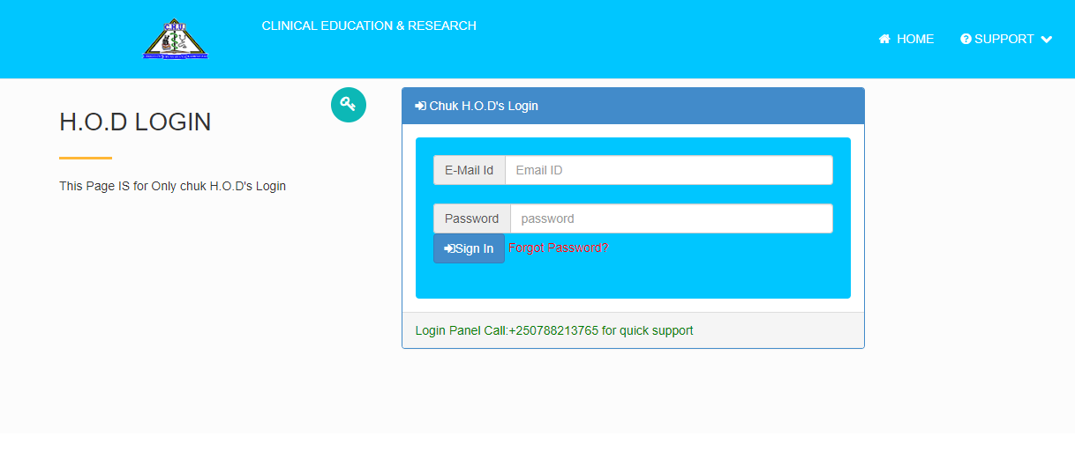

4th step
Click setting to change password

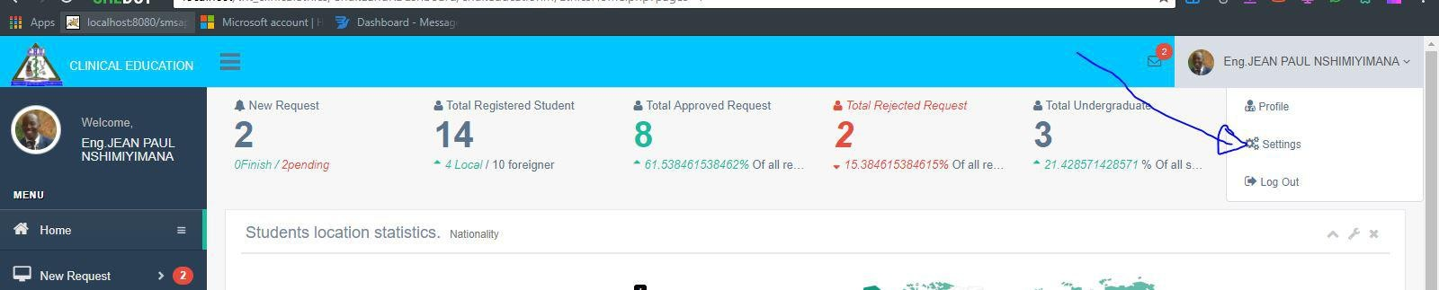

Last step

Enter new password and confirm
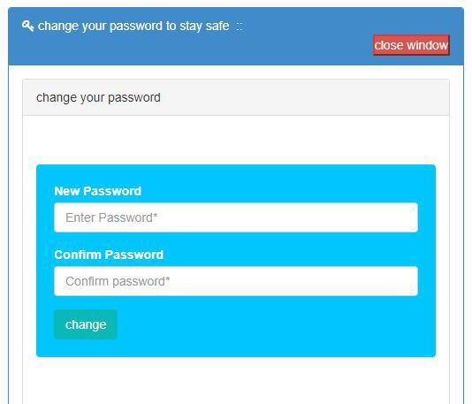

For more information please feel free to contact support team: Chuk.internship@gmail.com
internship@chuk.rw
+250788213765,+250784439238

THANKS……………………………………………………………………….!!

