STEPS TO DOWNLOAD Review_Approval_Notice:

1st STEP: LOGIN INTO THE SYETM[www.chuk.rw/research]
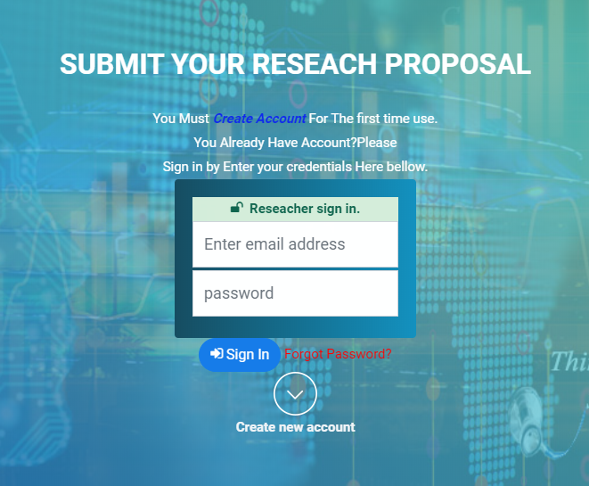

2nd STEP: CLICK APPROVED PROPOSAL BUTTON ON LEFT PANEL

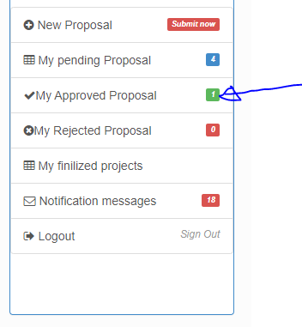

3rd STEP: CHOOSE PROPOSAL :
On the table list of Your approved proposal click view button.
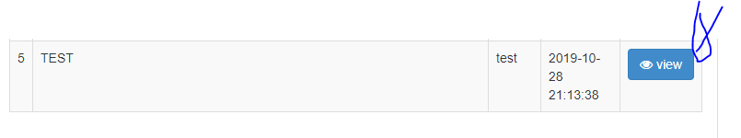
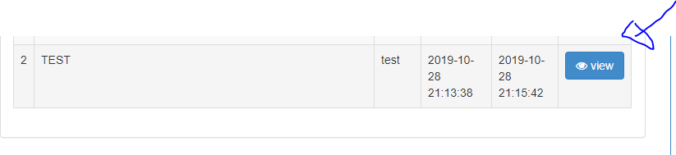

4th STEP: CLICK Review Approval Notice BUTTON:

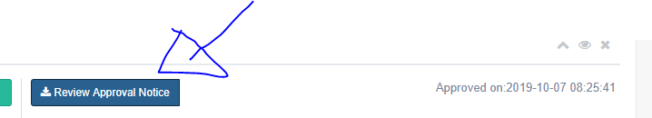
Remember that Only PDF file type And 2MB MAX size allowed
------------------------------------------------------------------------------------------------------------------------------------
IT SUPPORT CALL:+250788649898,research@chuk.rw

THANKS ….......!!!!!!!!!!!!!

