CHUK CLINICAL EDUCATION AND RESEARCH ONLINE SYSTEM

HOW TO ACCESS RESEARCH SYSTEM AS ETHIC COMMITTEE MEMBER?
1st LINK TO USE
Use the following link to access system portal: www.chuk.rw/research
2nd SCROLL DOWN TO THE BOTTOM OF THE PAGE AND CLICK PANEL LOGIN
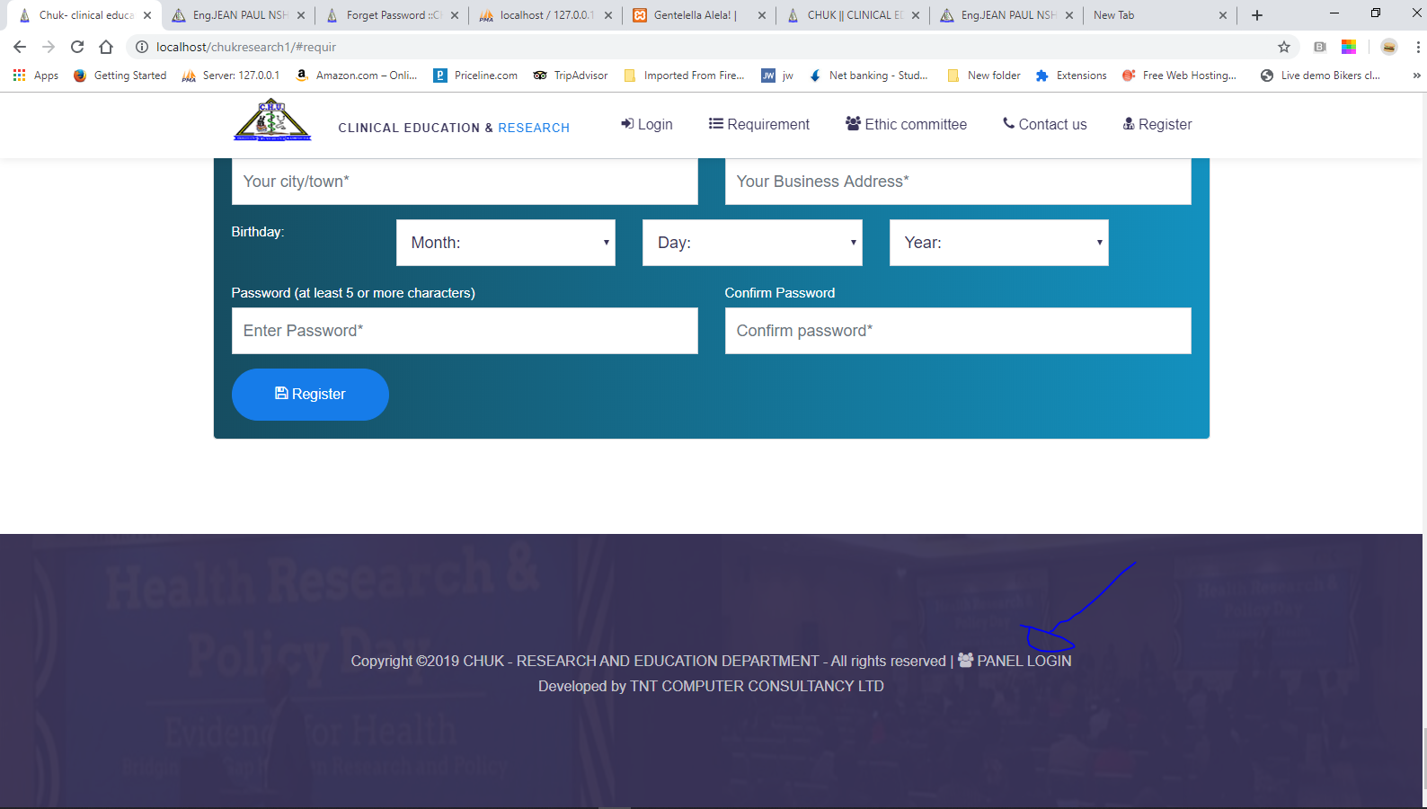
3rd ENTER YOUR CREDENTIALS
ENTER YOUR EMAIL AND PASSWORD
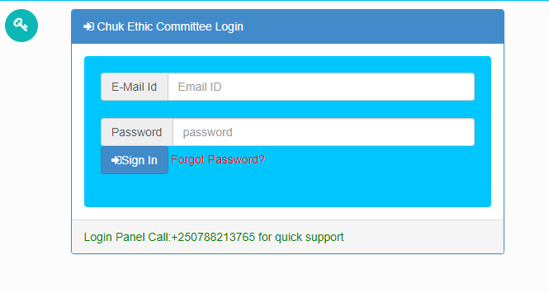
And then change your password

