STEPS TO UPDATE PROPOSAL DOCUMENTS:

1st STEP: LOGIN INTO THE SYETM[www.chuk.rw/research]
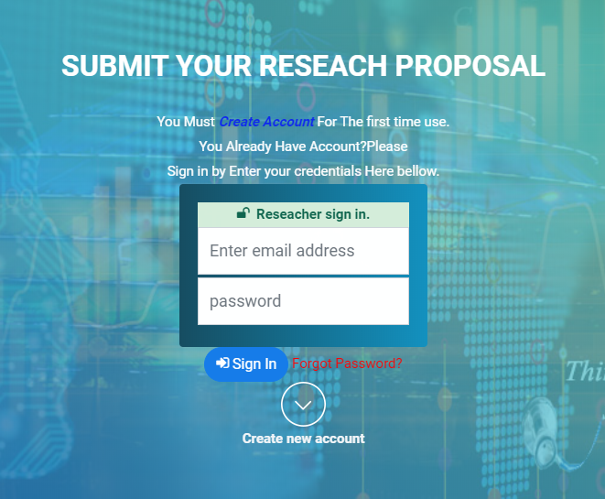

2nd STEP: CLICK PENDING PROPOSAL BUTTON ON LEFT PANEL

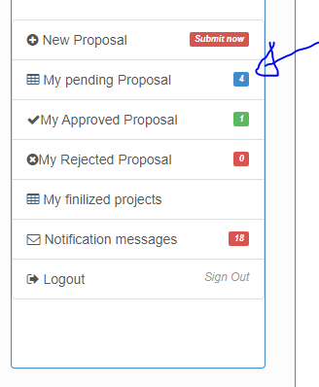

3rd STEP: CHOOSE PROPOSAL TO UPDATE:
On the table list of pending proposal click view button.
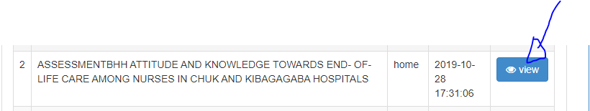

4th STEP: CLICK UPDATE BUTTON:

All files have update button. Please click that button on file you need to update
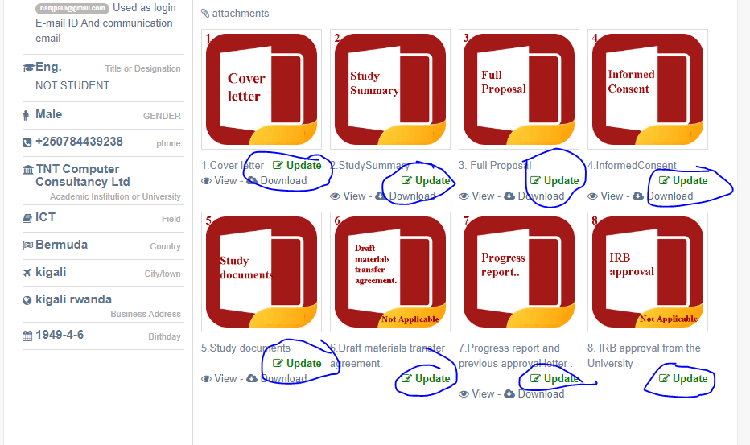
Remember that Only PDF file type And 2MB MAX size allowed
------------------------------------------------------------------------------------------------------------------------------------
IT SUPPORT CALL:+250784439238,chuk.research@chuk.rw

THANKS ….......!!!!!!!!!!!!!

